Why You Keep Becoming
the Person You Promised
Yourself You'd Stop Being

A neuroscience-informed guide to understanding your Survival Self and reconnecting with the woman you were always meant to be.

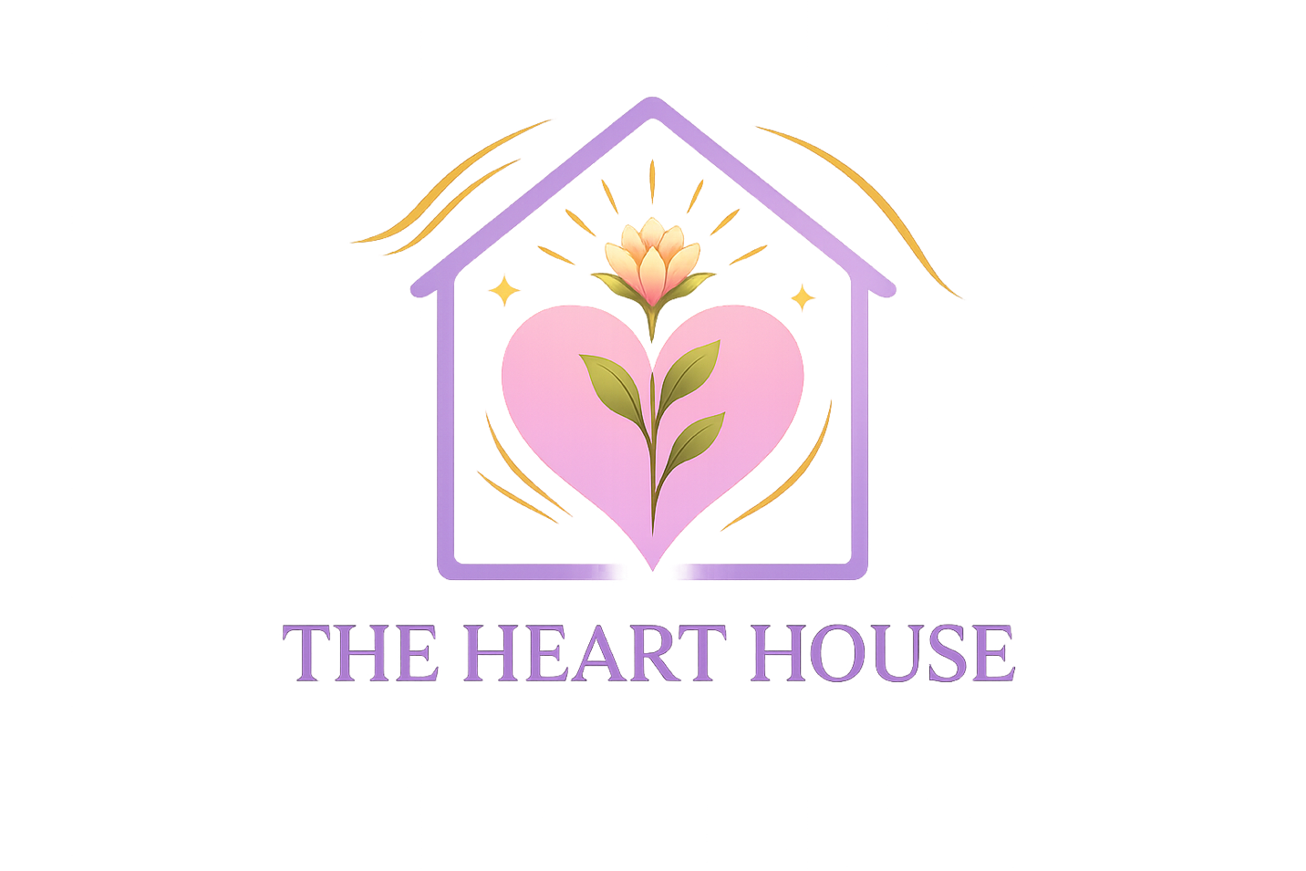

Dr. Valarie Anne Yerdon · The Heart House Method™
The Heart House, LLC · Heart House on the Hill
www.thehearthousemethod.com · www.hearthouseonthehill.com

You Are Not the Problem.
The pattern is.

There is a version of you that shows up when life feels threatening — when the stakes are high, when someone gets too close, when you sense criticism or rejection or the familiar edge of something that once hurt you deeply.
This version of you is not bad. She is not weak. She is not evidence that something is wrong with you. She is your Survival Self — the version of you that was built, long before you were old enough to understand what was being built, to protect you from pain.
She is remarkably good at her job.
The challenge is that she does not always know when the danger has passed. She applies yesterday's solutions to today's circumstances. She runs the same protective programs in your marriage that she developed in childhood. She keeps you safe from things that are no longer threatening and, in doing so, sometimes keeps you from things you genuinely want.
This guide is about understanding her. Not criticizing her. Not trying to eliminate her. Understanding her — with the same compassion you would offer any person who learned to survive something difficult and simply never got the message that it was over.
Because here is what I have come to know, through both the science I have spent years studying and the life I have spent a lifetime living:

The patterns you are most frustrated with in yourself
are almost certainly the ones that once kept you safe.

Understanding that changes everything.
Not as an excuse to stay where you are. As a doorway into the compassion that makes genuine change possible.
Let's walk through it together.

"The Survival Self is not who you are. It is who you learned to be. The Best Self is not who you are becoming. It is who you already are — waiting to be returned to."

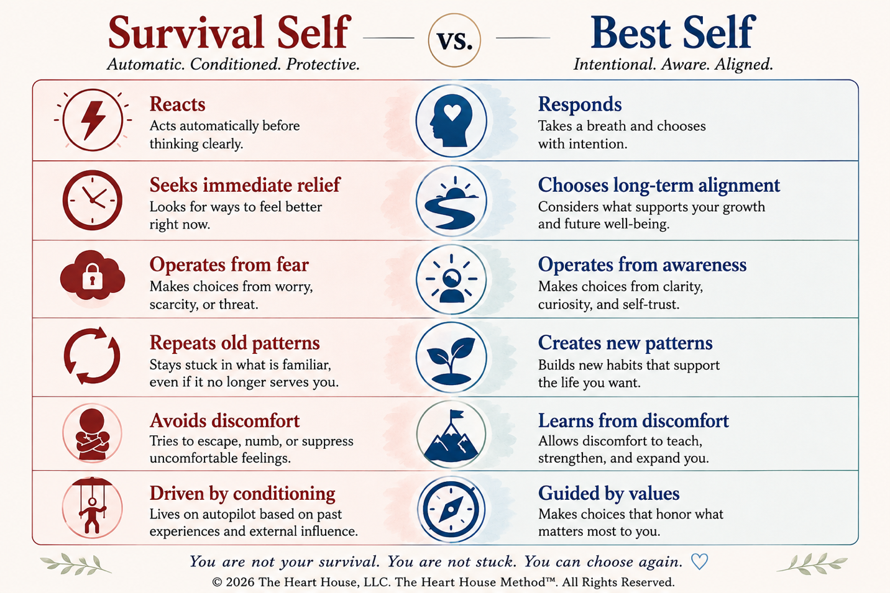

Understanding the Survival Self
The Survival Self is the set of patterns, beliefs, and responses your nervous system developed in order to navigate difficulty.
Every human being has one. It is not a flaw. It is the result of an extraordinarily intelligent system — your brain — doing exactly what it was designed to do: learn from experience and repeat what worked.
The Survival Self often sounds like:

"If I stay in control, I won't get hurt."
"If I keep everyone happy, I'll be safe."
"If I work hard enough, I'll finally be enough."
"If I don't let anyone too close, they can't leave."
"If I stay alert, I can prevent the bad thing from happening."

These are not character flaws. They are conclusions drawn by a younger version of you — sometimes very young — from real experiences with real consequences. The nervous system absorbed them as truth, reinforced them through repetition, and eventually made them automatic.
So automatic, in fact, that they stopped feeling like strategies.
They started feeling like personality.
This is why you might find yourself repeating patterns you genuinely want to change. Not because you lack willpower or awareness. But because the pattern is not operating at the level of willpower or awareness. It is operating at the level of the nervous system — faster and deeper than conscious intention can reach without specific, intentional support.
What the Survival Self Looks Like in Practice
The Survival Self shows up differently depending on what your nervous system learned. But some of the most common expressions include:

→ People-pleasing and over-responsibility
Caring for everyone else at the expense of yourself because somewhere you learned that being useful created safety.
→ Emotional walls and self-reliance
Keeping people at a careful distance because vulnerability was once met with pain rather than care.
→ Hypervigilance and overthinking
Staying perpetually alert because unpredictability was once dangerous and your nervous system never fully received the signal that the danger passed.
→ Achievement as worth
Tying your value to your productivity because being capable once earned the approval or safety you needed.

You may recognize yourself in one of these clearly. You may find yourself in more than one. Whatever you see — that recognition is the beginning.

"Most behaviors make complete sense once you understand the story beneath them."

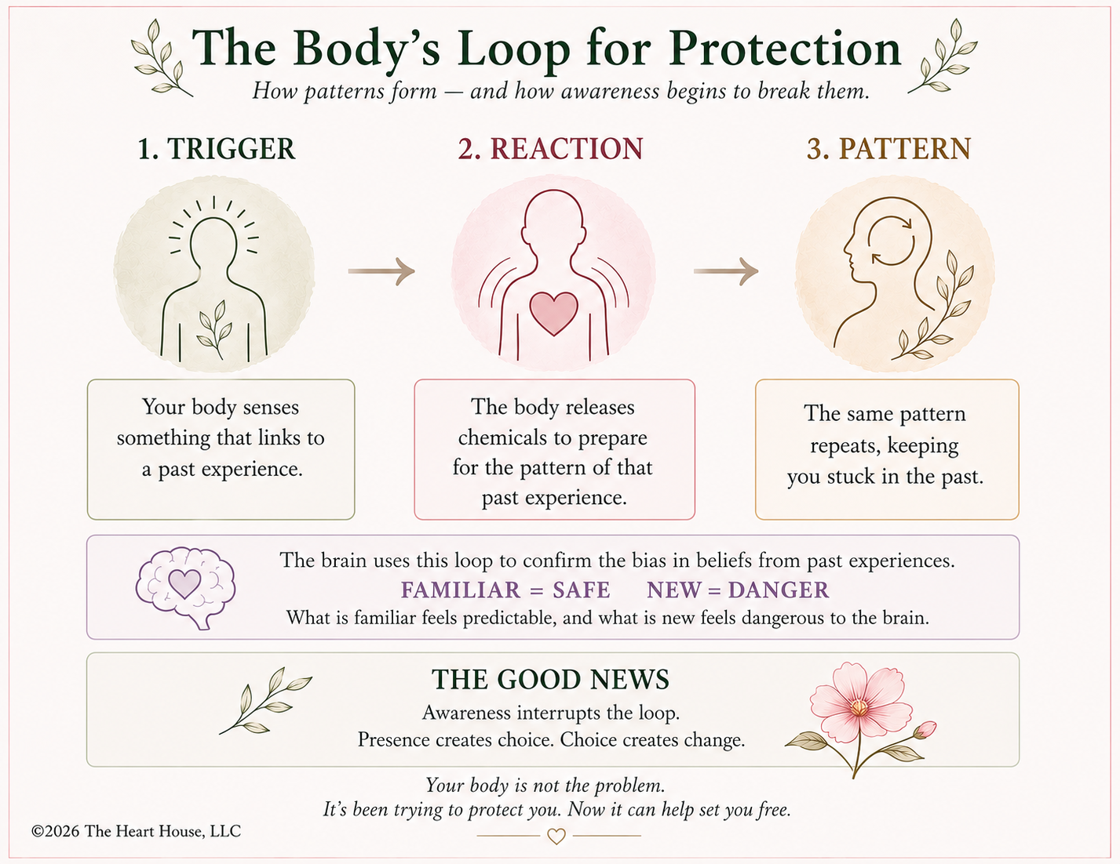
Understanding Your Best Self
Your Best Self is not a future version of you that arrives after enough healing.
She is not a perfected, improved, finally-got-it-together version that exists at the end of some long process of becoming. She is not someone you have to construct from scratch or discover through extraordinary effort.
She is already here.
Your Best Self is the version of you that exists beneath the survival strategies — the one who has always been there, underneath the people-pleasing, underneath the walls, underneath the vigilance, underneath the striving. She did not disappear when the patterns formed. She simply got very quiet. She learned to wait.
She is the part of you that knows what you actually value when no one is watching. That recognizes when something is out of alignment before your conscious mind has processed why. That longs for connection, for rest, for the freedom to be known rather than only useful, for the experience of being enough without proving it.
The Best Self does not operate from fear. She operates from values. From truth. From the deep, pre-pattern knowledge of who you are when survival is not the primary requirement of the day.
The Old Path and the New Path
The Survival Self travels the old path — the one that is deeply grooved, well-worn, fast, and automatic. It requires very little energy because it has been traveled thousands of times. It feels like the only way forward even when it is taking you somewhere you no longer want to go.
The Best Self travels a new path. At first this path is unfamiliar, slower, and more effortful. The brain resists it not because it is wrong but because it is unused. New paths require conscious intention. They require the willingness to feel the discomfort of unfamiliarity and keep going anyway.
But here is what neuroplasticity teaches us:

Every time you choose the new path,
you make it slightly more traveled than before.
And eventually — through repetition, through safety,
through the patient practice of something truer —
the new path becomes the one your nervous system reaches for first.

That is not a metaphor. That is neuroplasticity. That is the literal mechanism through which lasting change occurs.
And it is available to you.

Old Path: Automatic, familiar, fast, built from survival.

New Path: Intentional, chosen, built from values and self-knowledge.

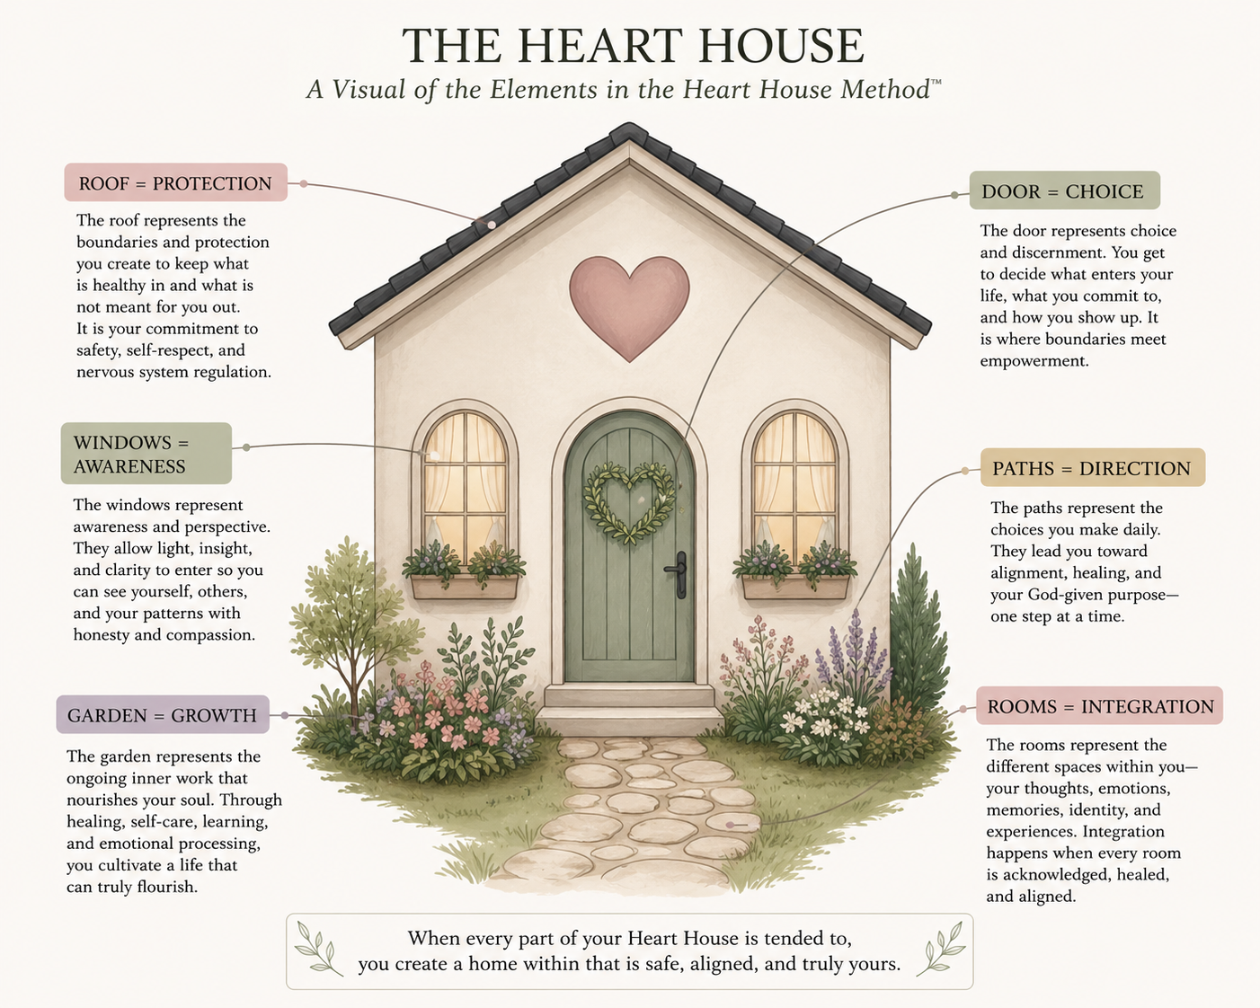

Worksheet One
Recognizing Your Survival Self in Action
Think of a recent situation where you felt emotionally activated — anxious, reactive, withdrawn, over-responsible, or stuck in a pattern you recognized but couldn't stop.
Use the questions below to explore what was happening beneath the surface. You are not looking for the right answer. You are looking for honest observation.

The Situation
Briefly describe what happened. Just the facts — what was said or done.

______________________________________________________________________
______________________________________________________________________
______________________________________________________________________
______________________________________________________________________

The Reaction
What did you do, say, or feel? How did your body respond? What did you want to do even if you didn't?

______________________________________________________________________
______________________________________________________________________
______________________________________________________________________
______________________________________________________________________

The Protection
What was your Survival Self trying to protect you from in that moment? What did it believe was at stake?

______________________________________________________________________
______________________________________________________________________
______________________________________________________________________
______________________________________________________________________

The Root
Have you felt this way before — not necessarily in the same situation, but the same feeling? When is the earliest you remember it?

______________________________________________________________________
______________________________________________________________________
______________________________________________________________________
______________________________________________________________________

The Best Self Response
If your Best Self — regulated, grounded, clear on her values — had been present in that moment, what might she have done or said differently?

______________________________________________________________________
______________________________________________________________________
______________________________________________________________________
______________________________________________________________________

You do not have to have perfect answers here. The noticing is the work.
Awareness is not the destination. It is the doorway.

Worksheet Two
Survival Self vs. Best Self Inventory
Complete the sentences below for both columns. Be honest rather than aspirational. The Survival Self column is not a list of failures — it is a map of what your nervous system has been protecting.

When I'm in my Survival Self... | When I'm in my Best Self...
I react quickly with defensiveness or withdrawal. | I pause before responding and choose my words with intention.
I say yes before checking whether I have capacity. | I check in with myself before I check in with the need.
I manage others' feelings before my own. | I notice my own feelings first and tend to them honestly.
I keep moving to avoid feeling what is here. | I allow myself to be still and feel what is present.
I prove my worth through what I produce. | I rest in the knowledge that my worth is not performance-dependent.
I keep people at a careful distance. | I allow safe people to know me more fully.
I prepare for everything to protect against the worst. | I trust myself to respond to what actually arrives.
I disappear into other people's needs. | I remain present to myself while caring for others.

Now add your own — the patterns that feel most familiar to you:

When I'm in my Survival Self... When I'm in my Best Self...
______________________________________________________________________
______________________________________________________________________
______________________________________________________________________
______________________________________________________________________

Look at what you wrote.
Neither column is who you are. Both columns are how you respond — and responses can change.

The Heart House
The Heart House is not a metaphor for something abstract.
It is the internal structure you return to when the survival strategies are no longer running the show. The place within you where your values exist without distortion. Where your identity exists without adaptation. Where your truth exists without conditioning.
It is not something you build from nothing. It is something you rebuild — by learning to recognize when you have left it, and by practicing the small, repeated, intentional act of returning.
That returning is the work. Not the dramatic transformation. Not the single breakthrough moment. The quiet, daily practice of noticing when you have drifted toward the old path — and choosing, one breath at a time, the new one.

"Transformation is not about fixing yourself. It is about understanding the house you have been living in and intentionally creating the one you want to inhabit moving forward."

What This Work Actually Produces
When women do this work — when they genuinely explore the roots of their survival patterns, develop a regulated nervous system, and begin building new pathways from the inside out — something specific happens.
They stop being surprised by their own reactions.
They start being able to pause where they used to only be able to react.
They find that rest stops feeling guilty and receiving stops feeling dangerous.
They discover that the people around them experience them differently — not because they have become someone else, but because they are more fully themselves.
And they begin, sometimes slowly and sometimes all at once, to feel the particular quality of peace that comes when your internal life and your external life are no longer in constant conflict.
That is not a program outcome.
That is what happens when a person
finally comes home to herself.

And it is available to you.
Ready to Go Deeper?
This guide is the beginning of a conversation your nervous system has been trying to have with you for a long time.
The Heart House Method™ takes that conversation further — much further — through a structured, neuroscience-informed, faith-integrated coaching process that goes beyond awareness into the embodied, daily, genuinely lived experience of change.
It is not surface-level. It is not about positive thinking or behavioral modification or simply deciding to do better. It is about understanding, at a level that goes all the way down, where your patterns came from — and building new pathways that are grounded in your actual values, your actual identity, and the truth of who you were always meant to be.
The Heart House Method™ Programs
Choose the depth that feels right for where you are. All programs use the guided 12-session workbook and are led in 1:1 coaching sessions with Dr. Valarie Anne Yerdon.

3 Sessions The Entry Introduction
For the woman who is ready to begin. Covers pattern recognition, the Survival Self and Best Self framework, and the core tools of the method. A meaningful entry point wherever you are in the journey.
6 Sessions The Foundation & Roots
For the woman who is ready to go beneath the pattern into its origins. Adds nervous system regulation, schema work, and the child root event timeline. Builds the interruption window into daily practice.
9 Sessions The Fundamental Path
For the woman who is ready to rebuild from the inside out. Includes identity work, relationships and boundaries, and the integration of the Heart House as a way of living rather than a concept to understand.
12 Sessions The Immersive Journey
For the woman who is ready for the full arc — from survival to healing to identity to purpose to generational legacy. The complete Heart House Method™ from foundation through expansion and sustainability.

You do not need to know which program is right before reaching out. The discovery call is designed to help you find the right entry point for exactly where you are.

Your pattern is not your destiny.
It is the place where your healing begins.

Schedule Your Complimentary Discovery Call

thehearthousemethod.com
Individual Virtual Coaching · 3, 6, 9, and 12-session programs Guided workbooks

The Heart House Method™
Where neuroscience meets soul alignment, healing, and lasting transformation.
© 2026 The Heart House, LLC · thehearthousemethod.com

